1- Design your online CV using the give template image

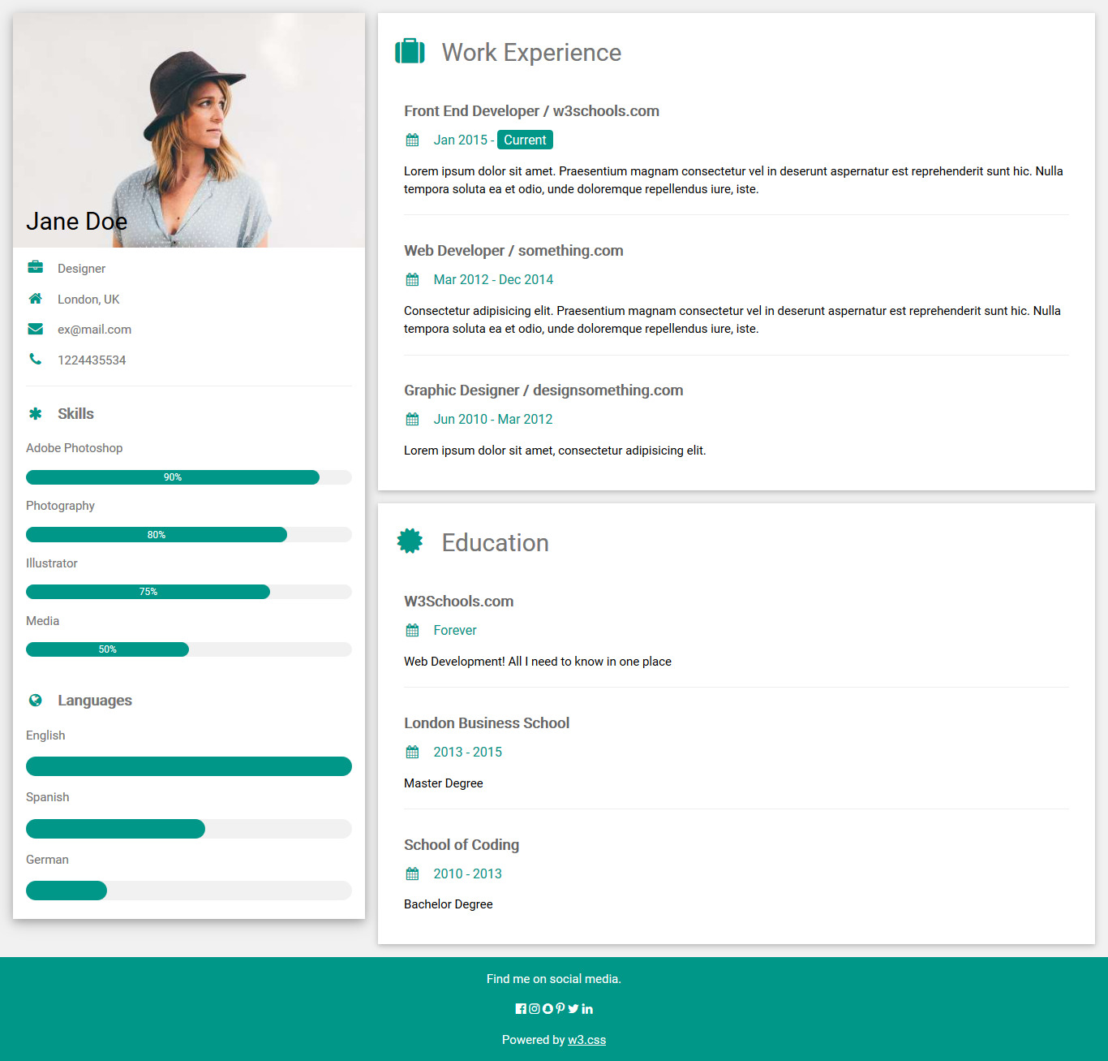

# 2-Complete on no 1 of day1 assignment

# a-Make Carousel

# b- Use Scrollspy